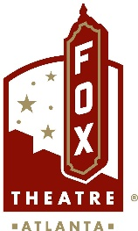
FOR MORE INFORMATION:
Sarah Wynn Benton
BRAVE Public Relations
404.233.3993
sbenton@emailbrave.com
FOR IMMEDIATE RELEASE

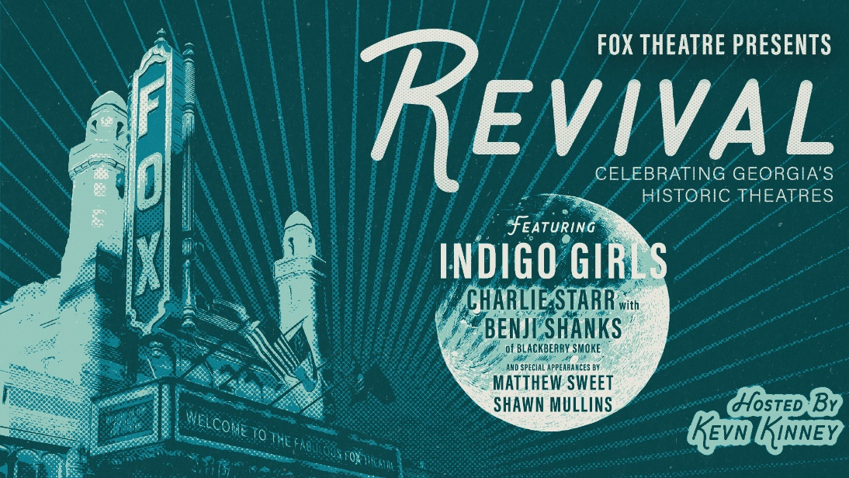

Fox Theatre Announces Revival Benefit Concert Featuring The Indigo Girls, Charlie Starr with Benji Shanks of Blackberry Smoke on April 28
Proceeds will support Georgia’s historic theatres
Tickets on sale now at foxtheatre.org

ATLANTA (April 12, 2024) – On Sunday, April 28, at 7:30 p.m., the Fox Theatre will host the Revival benefit concert to support Fox Gives, the theatre's outreach program dedicated to preserving Georgia's historic theaters and enhancing educational outreach in the arts. Featuring headliners The Indigo Girls and Charlie Starr with Benji Shanks of Blackberry Smoke, along with Matthew Sweet and Shawn Mullins, the event will be emceed by Atlanta’s own Kevn Kinney of Drivin n Cryin. The concert celebrates the pivotal role of theaters in community building through music and storytelling, aiming to rally substantial support for Fox Gives.

Tickets are on sale now and available at foxtheatre.org or by calling 855-285-8499. As an enhancement to their concert experience, attendees can purchase club-level seats in the Loge, granting access to the Marquee Club presented by Lexus. This exclusive area offers amenities such as gourmet food, rooftop access, private restrooms and more.

The evening will feature several key fundraising initiatives, including an exclusive pre-concert auction at the Marquee Club presented by Lexus. Guests with Marquee Club access can bid on unique packages including:

- Broadway Extravaganza: Tickets to Broadway shows in NYC and Atlanta, signed merchandise and a year-long $500 Insider Level Friends of the Fox membership.
- Artist Package: Includes signed memorabilia from musicians that have graced the Fox’s stage, tickets to "An Evening with Goose" in June, hotel accommodations and a $500 Friends of the Fox membership.
- Atlanta Sports Package: This includes four Xfinity Club tickets to a chosen Atlanta Braves game, a Red Deck parking pass, signed sports memorabilia, an Atlanta sports fan swag bag and more!
- Ultimate Fox Experience: A highlight of the auction, this package includes a private tour of the Fox Theatre, a private dinner for 10 at the Marquee Club, complete with beverage pairings by an in-house sommelier and a closing champagne toast on the rooftop terrace.
During the concert in the auditorium, the ROCKTIONEER™ will lead the "Fund-A-Mission" live auction. This exciting event will offer attendees the chance to directly support the "Fox in a Box" educational program, a cornerstone of Fox Gives that educates elementary students about the communal history of the Fox Theatre. Regions Bank, a venue sponsor and Official Bank of the Fox Theatre will double each donation made during this fundraiser, maximizing the impact of attendee contributions. Participants will also be able to win Golden Tickets, granting year-long access to Fox Theatre shows.

Last year, the Fox Theatre distributed $500,000 in grants to restore 12 historic theaters across Georgia, including The Strand in Marietta, Northwest Atlanta’s Grove Theatre and Fairburn’s Southside Theatre Guild. These funds have been instrumental in updating essential infrastructure like sound and lighting systems, helping these cultural landmarks reopen and thrive.

Leigh Burns, Director of the Fox Theatre’s community partnerships program, expressed enthusiasm about the event, "We're thrilled that Revival will feature renowned artists such as The Indigo Girls and Charlie Starr with Benji Shanks of Blackberry Smoke. This annual benefit is a celebration of our state's rich theater and music culture, bringing together fans and supporters in Atlanta for a memorable evening of performances and meaningful fundraising."
###

About the Fox Theatre
The Fox Theatre is one of Atlanta's premier venues for live entertainment, welcoming more than 150 performances a year in its 4,665-seat theatre. From concerts to ballets, comedy, and movies, the historic venue attracts more than 500,000 visitors annually. The theatre hosts over 100 annual private events like wedding receptions, trade shows, corporate meetings, and association functions in two fabulous ballrooms. The Fox’s premium Marquee Club, presented by Lexus, is a 10,000 sq. ft, three-story luxury bar accessible to all Club Level ticket holders or annual members of the Fox Theatre. As a 501(c)(3) nonprofit arts organization, the Fox Theatre stands today as a fiercely protected landmark and a nationally acclaimed theatre. The Fox Theatre proudly acknowledges its partners' generous support: Coca-Cola, Georgia Natural Gas, Georgian Terrace Hotel & Livingston Restaurant, Humana, Lexus, Northside Hospital, and Regions Bank. Tickets for all events are available at FoxTheatre.org, or toll-free at 855-285-8499. Stay connected by following the Fox Theatre on social via @theFoxTheatre on Instagram, Twitter, and Facebook.
Notable accolades include 2023 Billboard Magazine #2 Highest Grossing Theatre Worldwide (5,000 seats or less); 2023 VenuesNow Magazine #2 Year-End Top Stops (2,001-5,000 seats); 2022 IEBA Theatre of the Year; 2021 Billboard Magazine #1 Highest Grossing Theatre Worldwide (5,000 seats or less); 2021 Pollstar Magazine #2 Theatre Worldwide in Ticket Sales and 2021 VenuesNow Magazine #2 Year-End Top Stops (2,001-5,000 seats). Additionally, in 2019, the Fox Theatre was honored with the VenuesNow #1 Top Stop of the Decade Award for Tickets Sold, further cementing its reputation as a premier entertainment venue.

